Lesson 06 Demo 01

Backup Azure File share

Objective: To create a backup Azure file sharing under the Azure storage account to ensure the security and reliability of data within the Azure environment
Tools Required: Azure account

Prerequisites: None

Steps to be followed:
- Configure a storage account with file sharing
- Create a Recovery Services vault
- Configure file share backup
- Verify the file share backup
Step 1: Configure a storage account with file sharing

- Sign in to Azure Portal and locate the Storage accounts resource

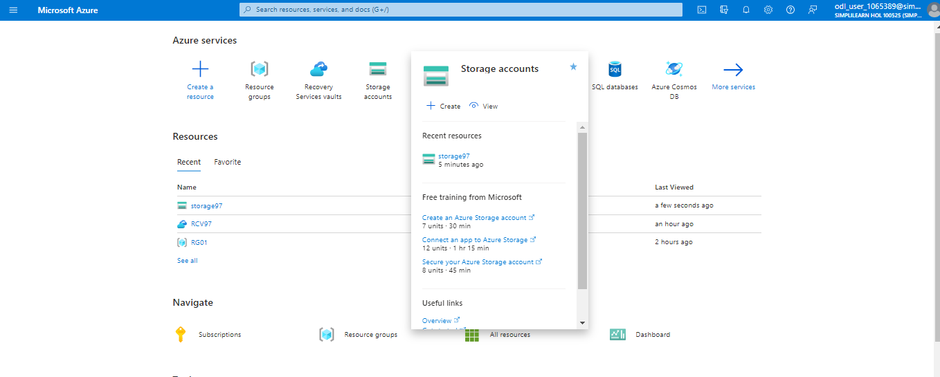

- Click on + Create

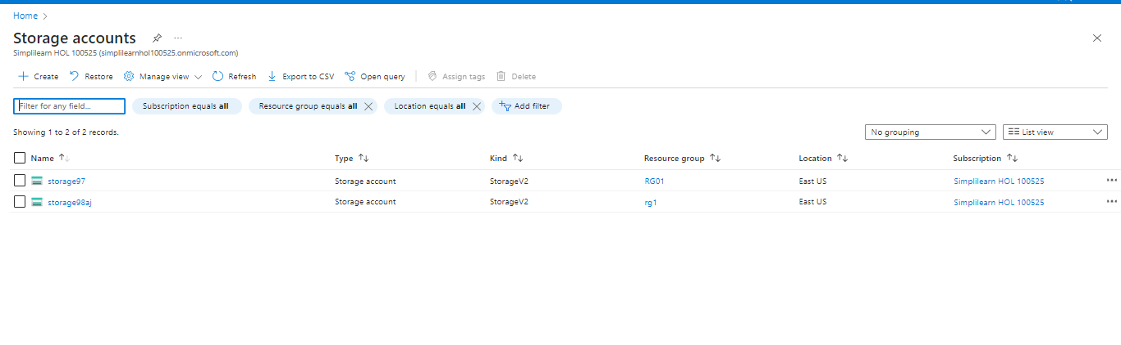

- Enter the information in the Basics tab and select Review

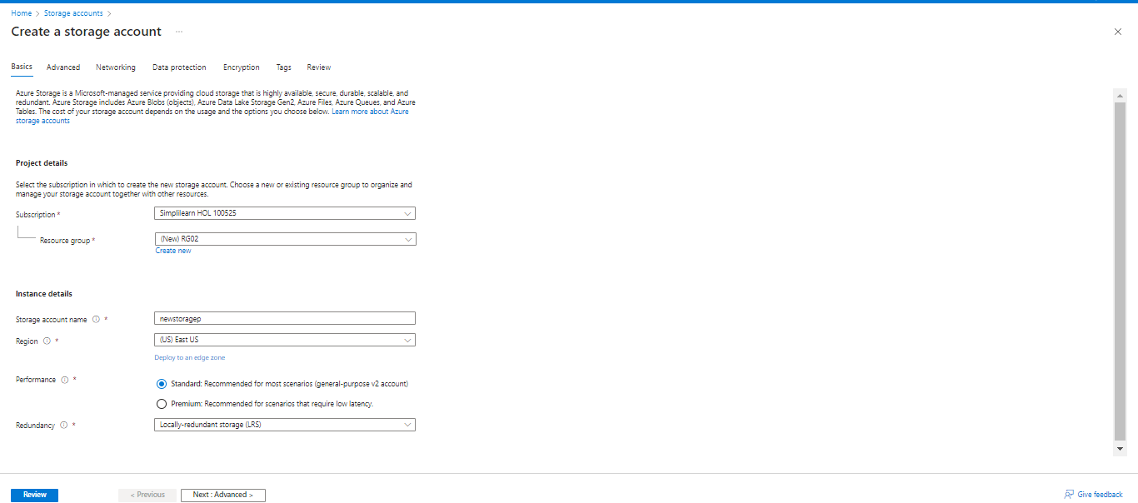

- Now, click on Create

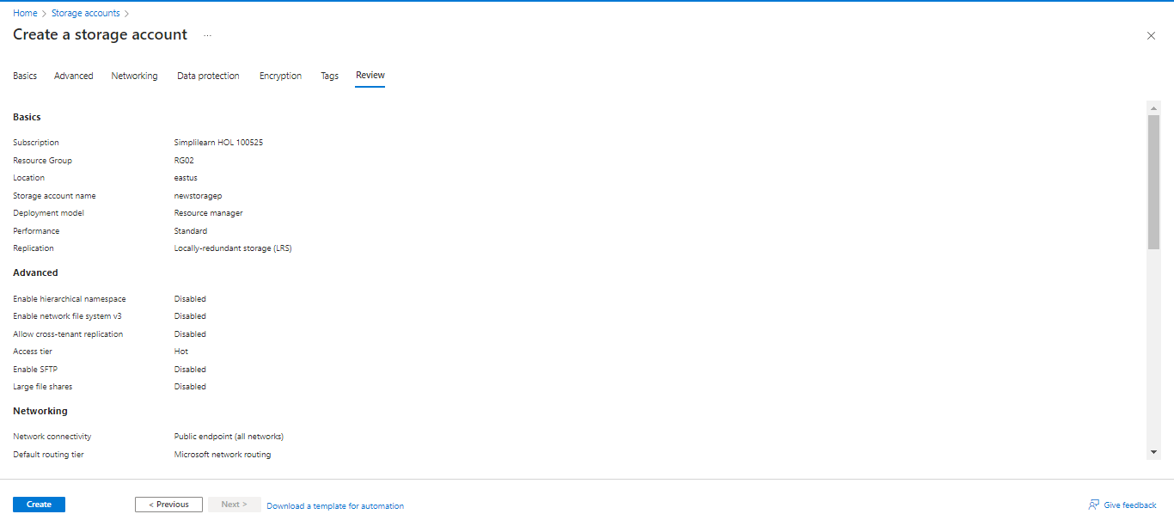

The created storage appears as follows:

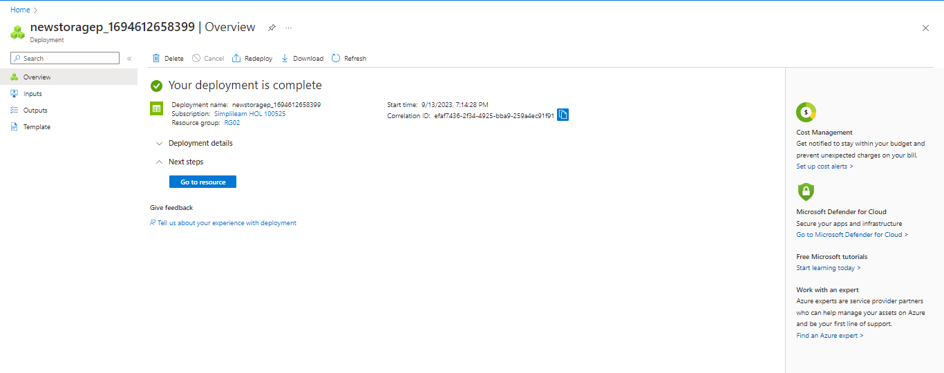

- Go to the storage account created in the previous step

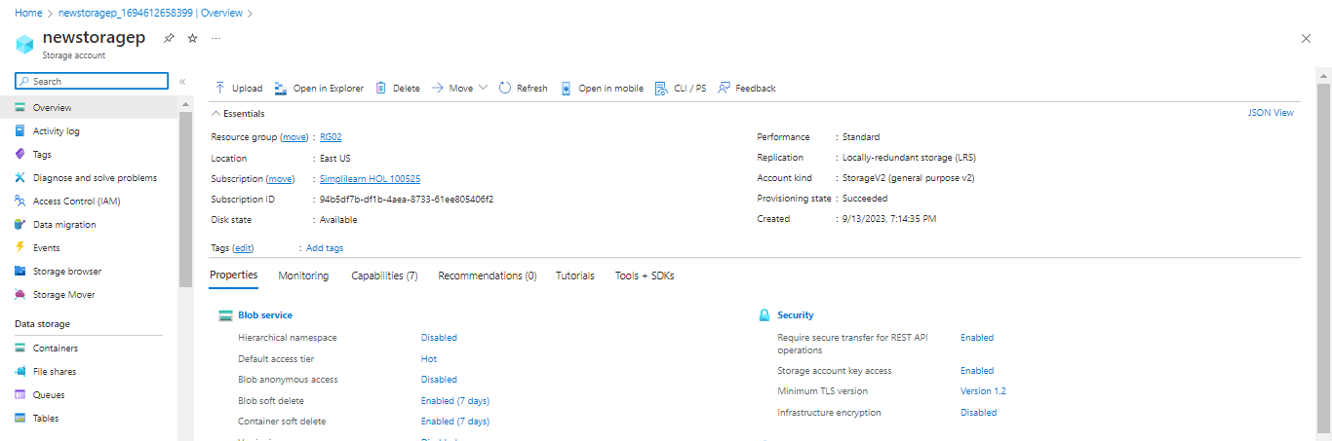

- Select File shares and click + File share

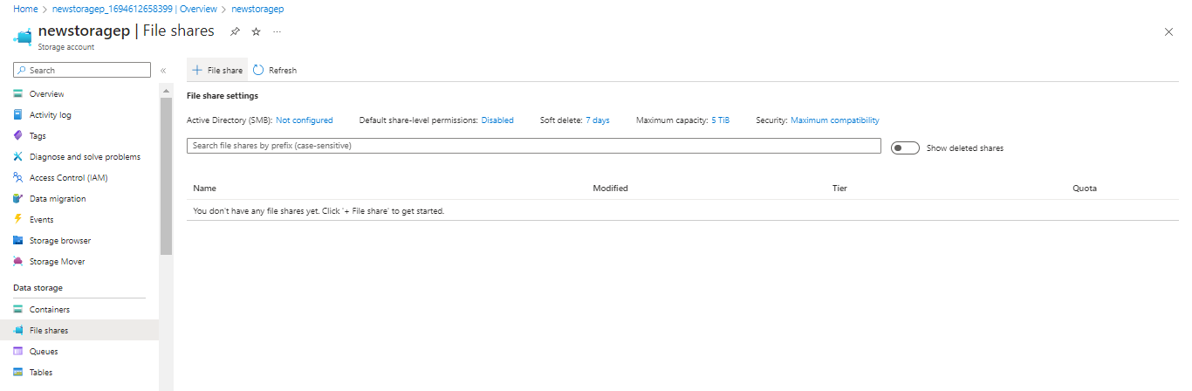

- Fill in the Basics tab and click on the Next: Backup > button

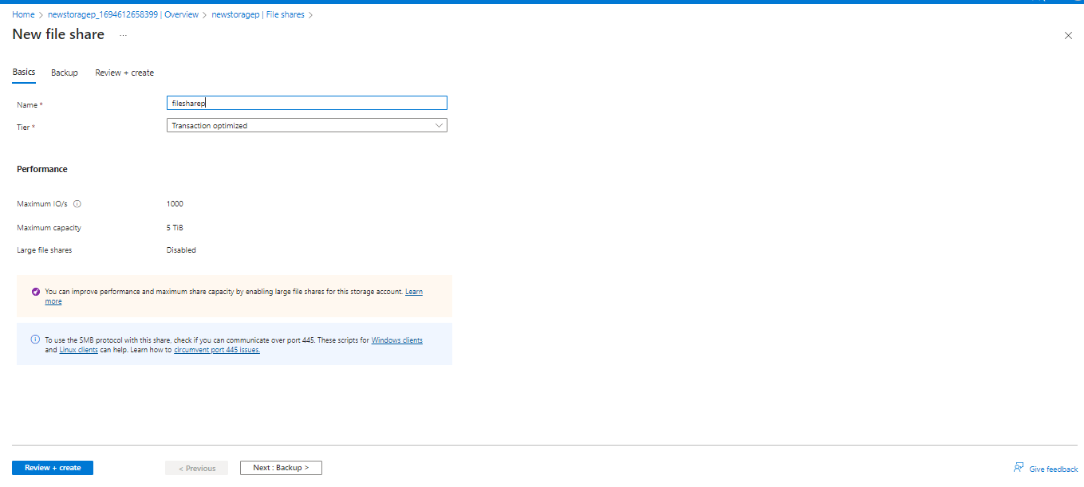

- Uncheck the Enable backup setting and select Review + Create>

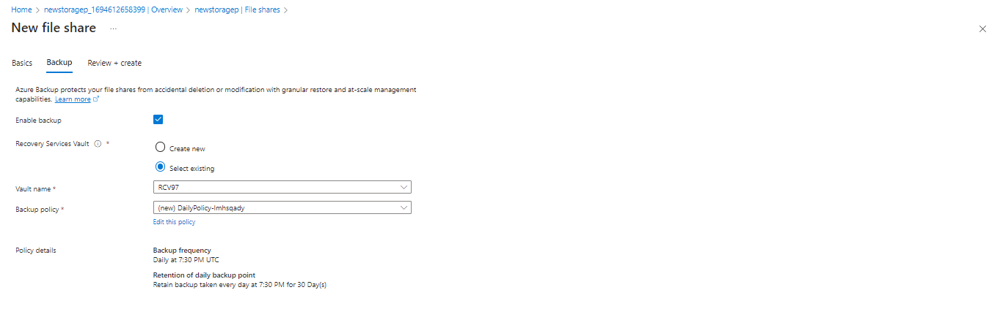

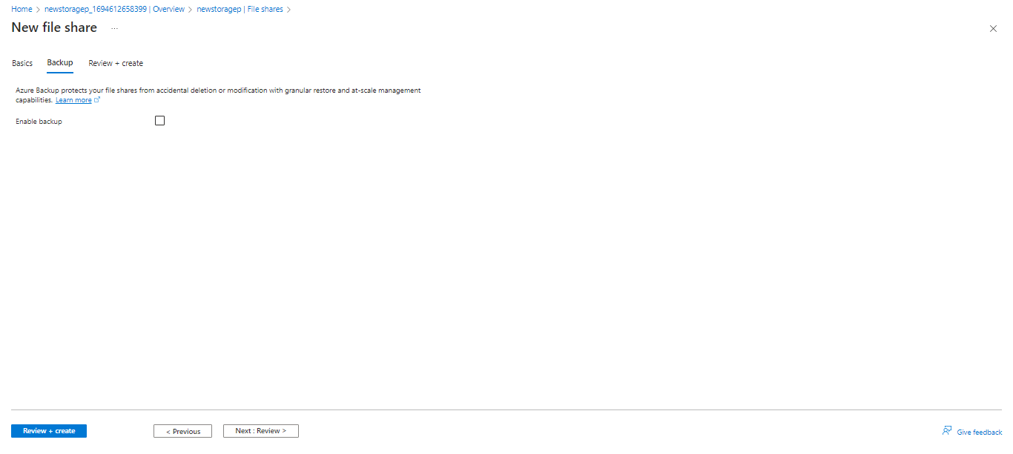

- Click on Create

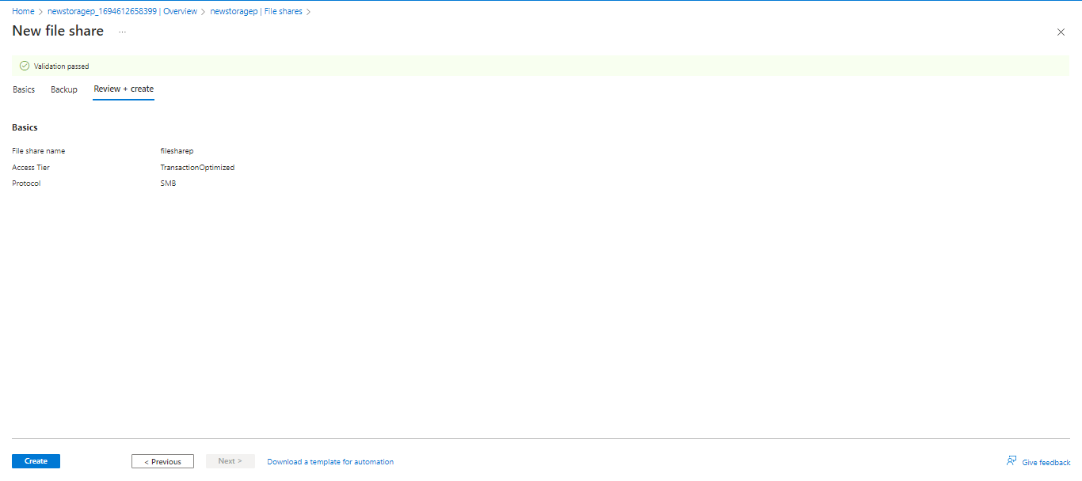

Step 2: Create a Recovery Services vault

- Locate the Recovery Services vaults

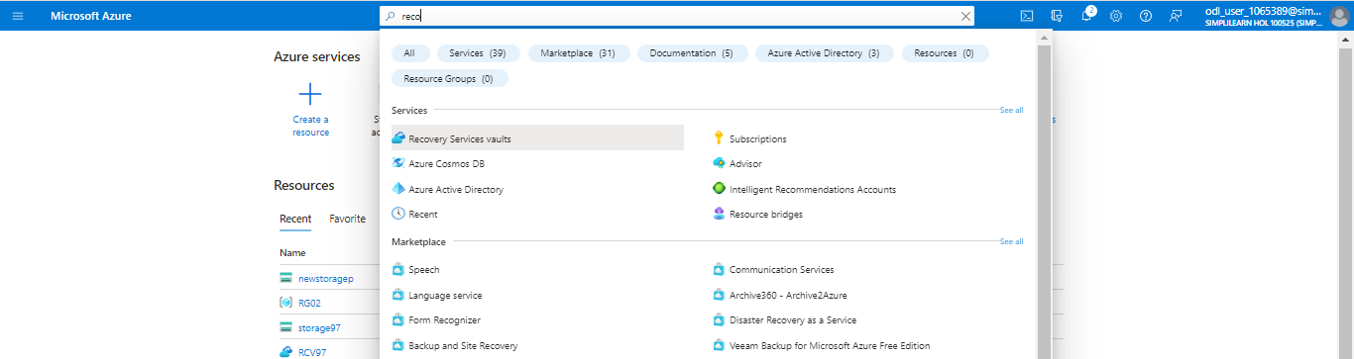

- Click on + Create

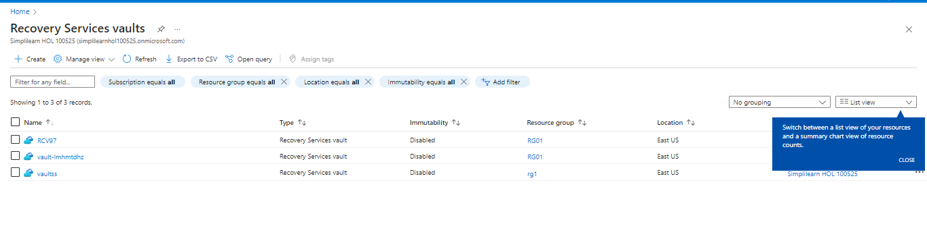

- Fill the Basics tab and select Review + Create

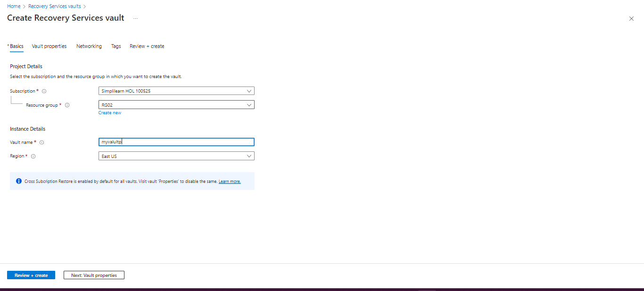

- Click on Create

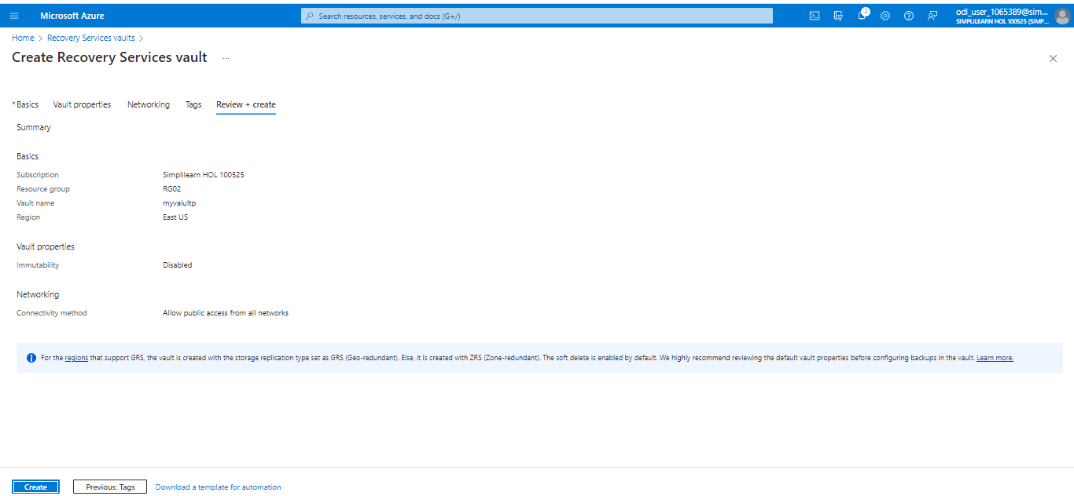

The recovery service vault appears as follows:

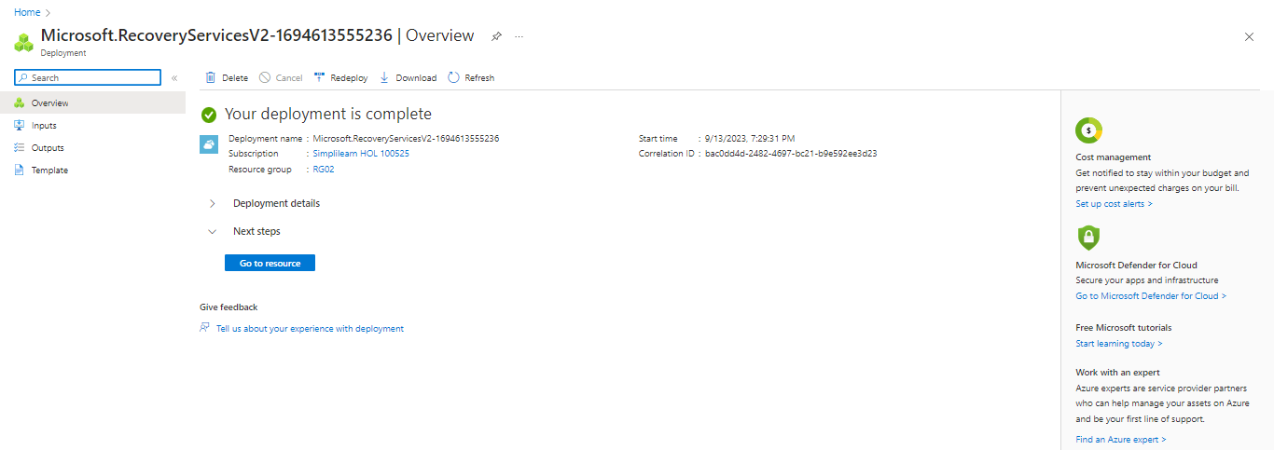

Step 3: Configure file share backup

- Open Recovery Services vaults created in the previous step

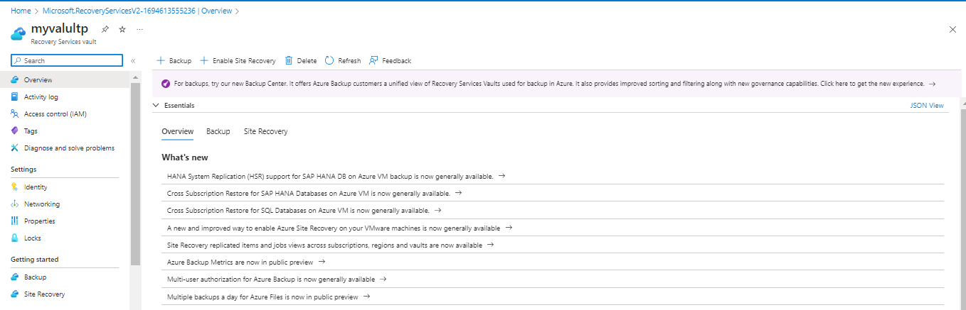

- Select Backup from the Getting started menu. Under What do you want to backup?, choose the Azure file share and select Backup

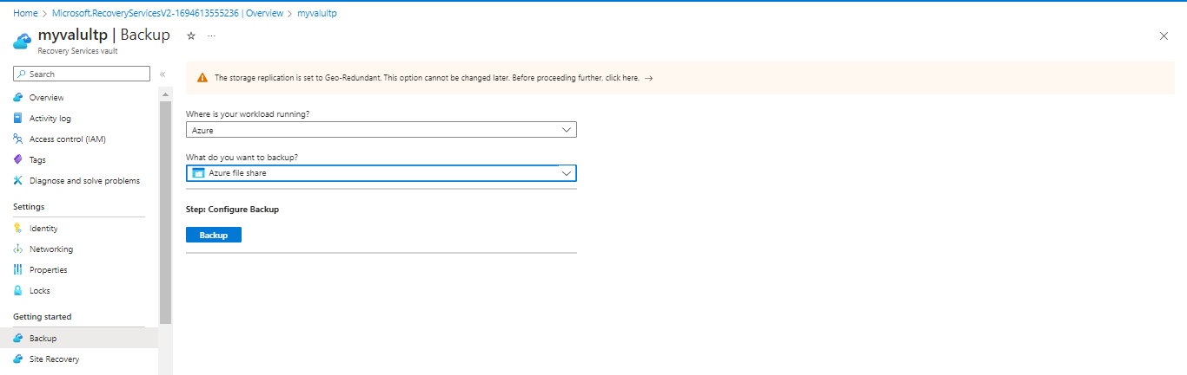

  - Under Storage Account, click on Select and wait until storage gets detected under Select storage account. Now, select the newstoragep.

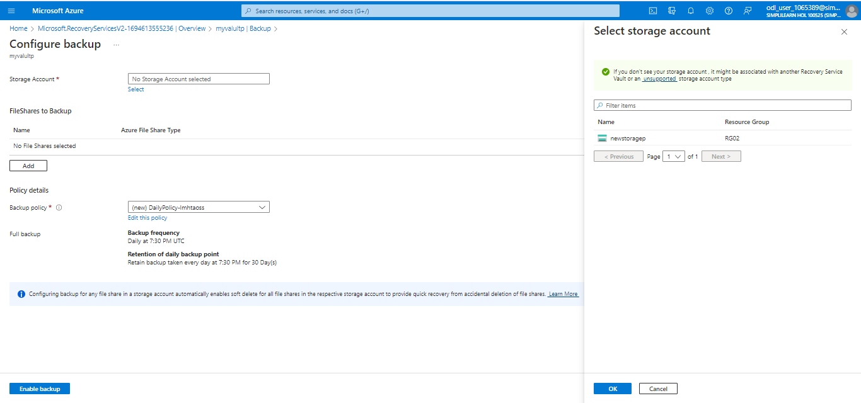

  - Click OK

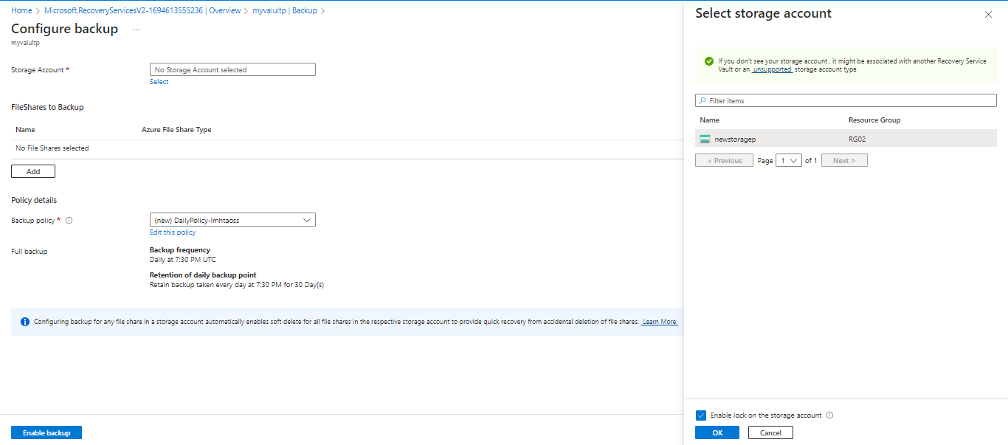

  - Click on Enable backup

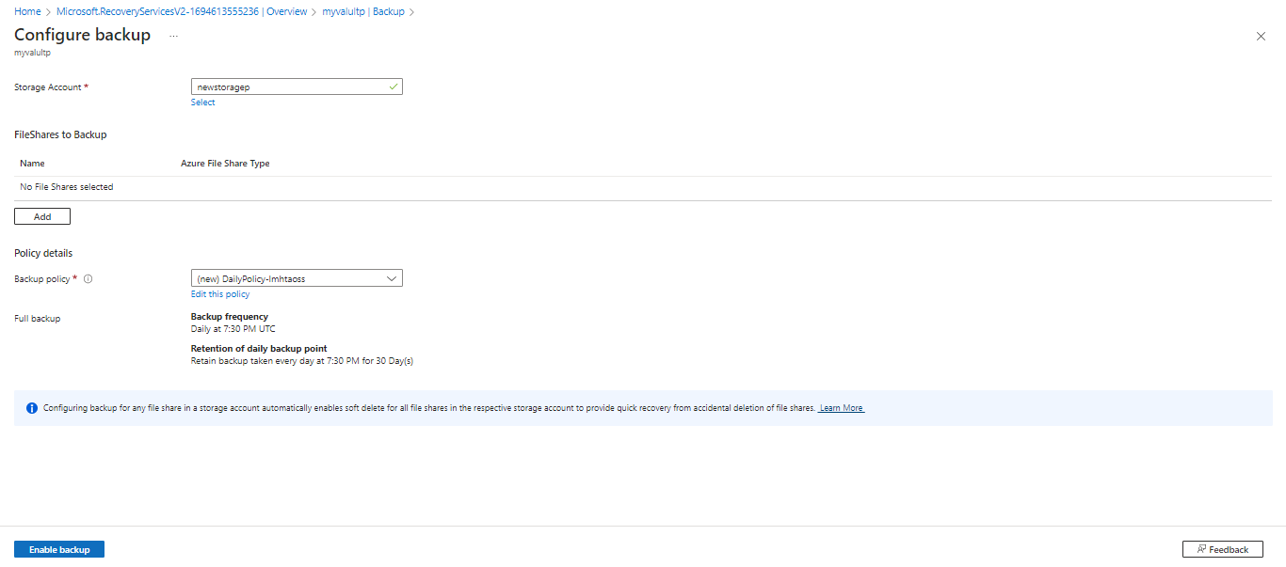

  - Click on Add, select filesharep, and click OK

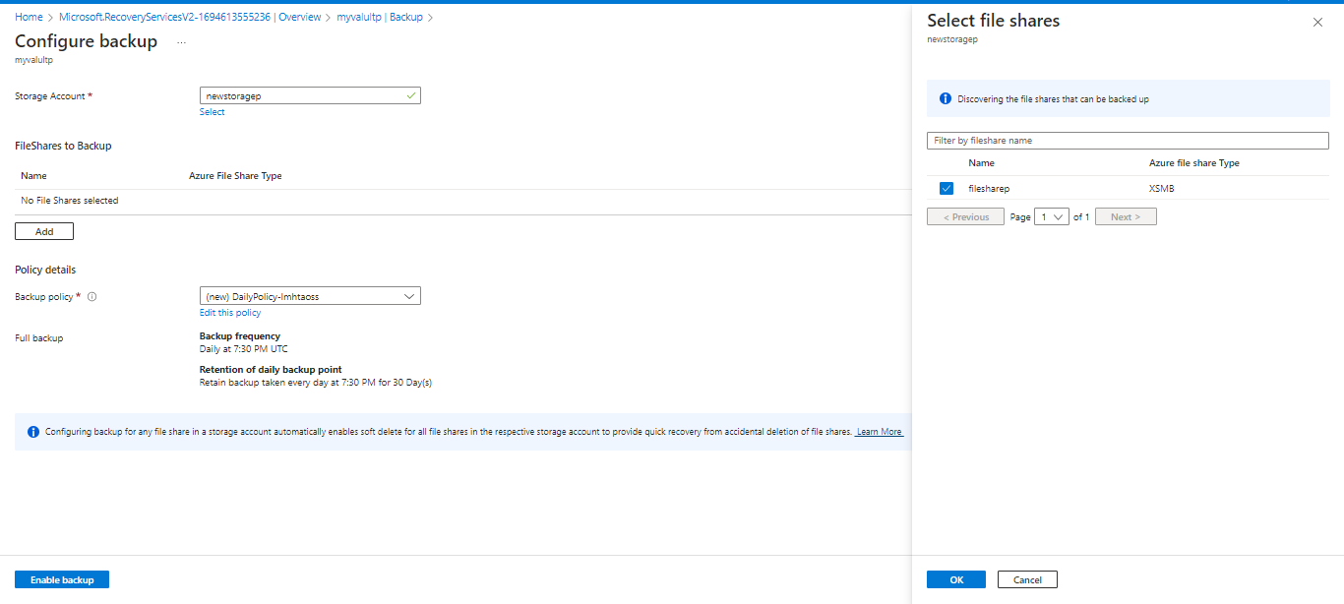

  - Click on Enable backup

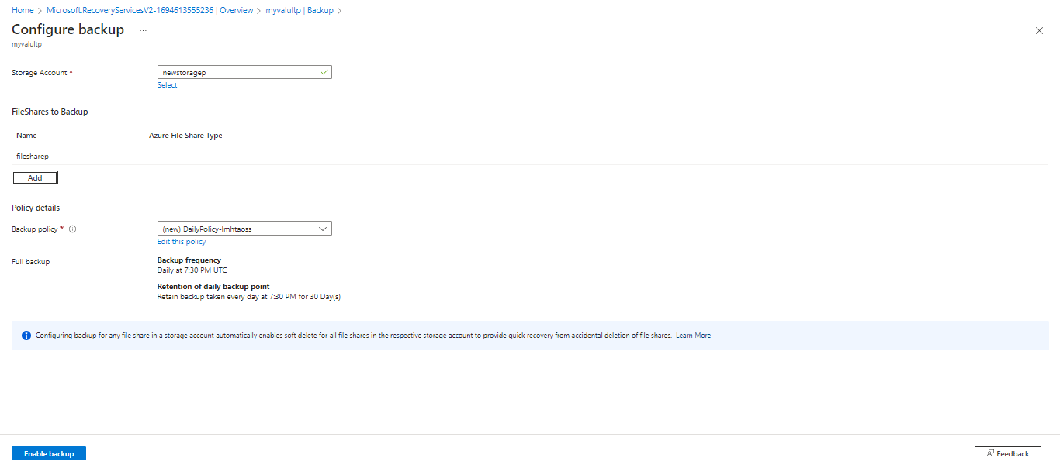

The output appears as follows:

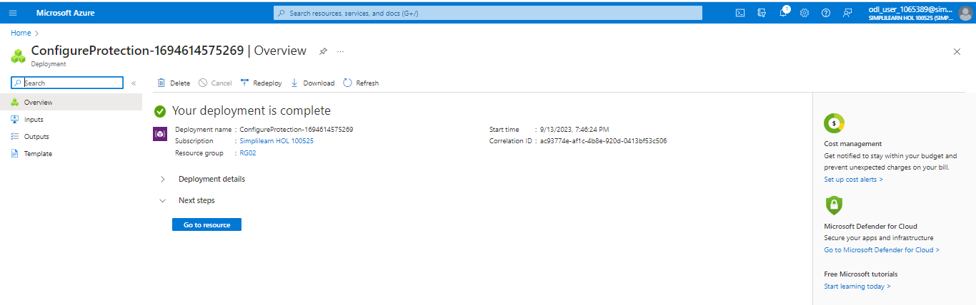

Step 4: Verify the file share backup

- Go to the Recovery Services vaults and select Backup items

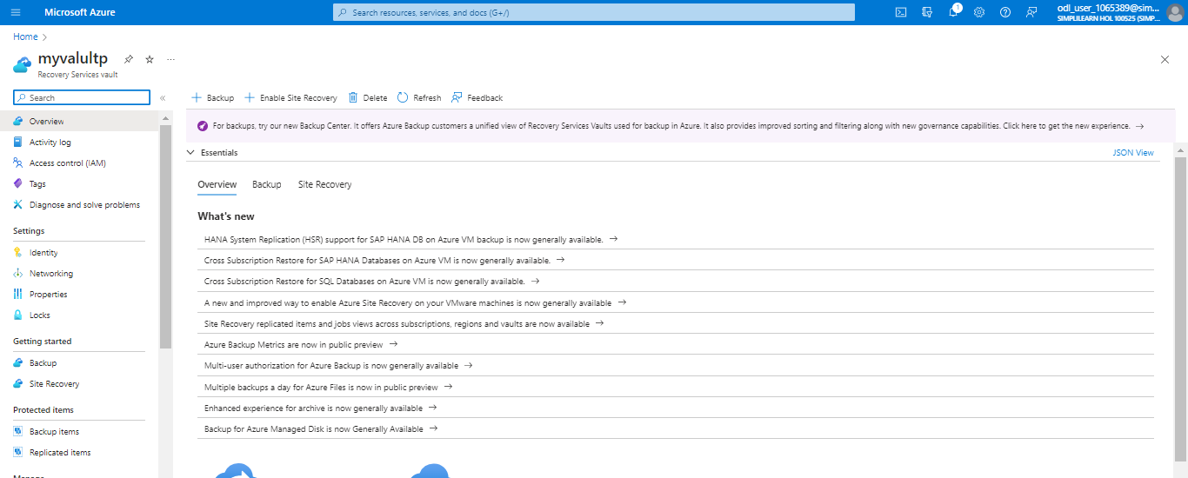

- Click on Azure Storage (Azure Files)

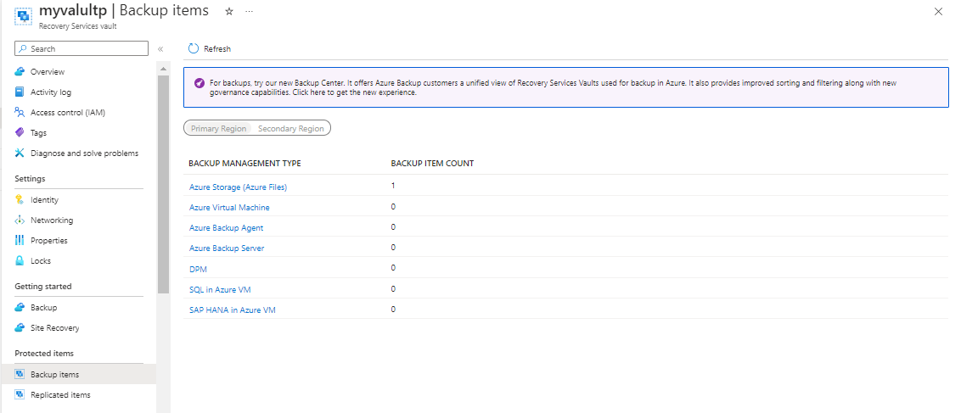

The final output appears as follows:

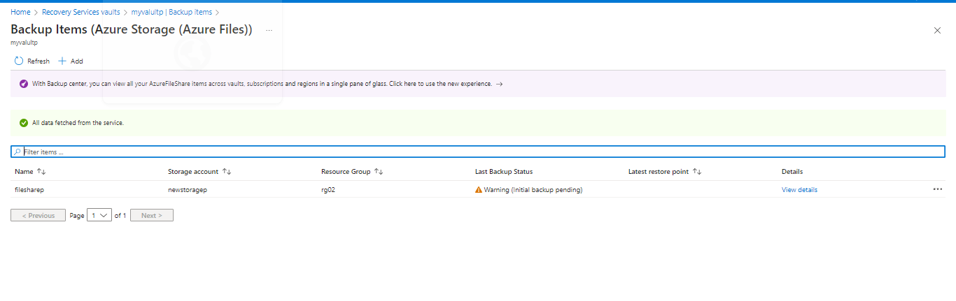

You have successfully taken the backup of the Azure file share created under the Azure storage account to ensure the security and reliability of data within the Azure environment.

